Fundamentals of DataBase
LAB
FAROOQ AHMAD EXPERIMENT 7
17L-4407
BEL-8A1
Views and Stored Procedures

Creating a View
Below is the general syntax for creating a View:
CREATE VIEW [View_Name]
AS
[SELECT Statement]
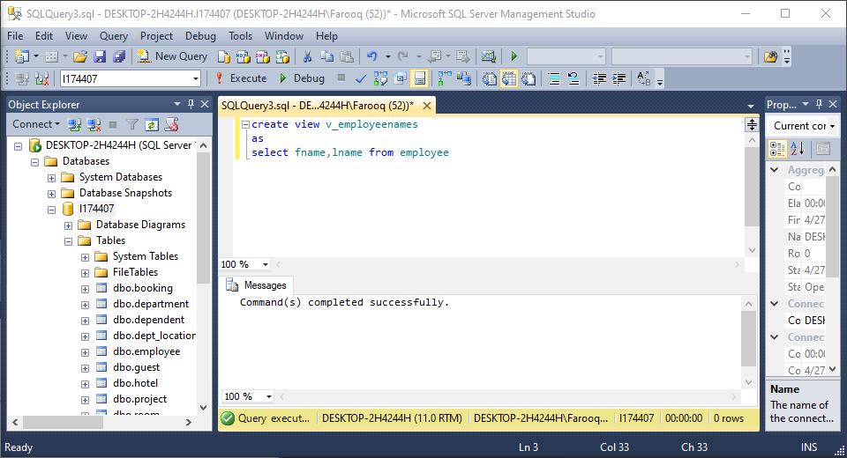
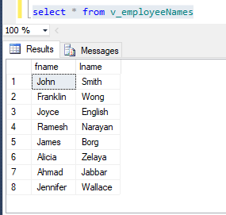
Get result from a View:
This is similar to a Select statement:

select * from v_employeeNames

Modify an existing View
Alter VIEW v_employeeNames
As
SELECT ssn, fname, lname FROM employee
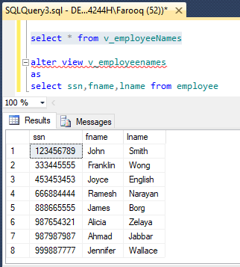
Drop a View

DROP VIEW v_employeeNames
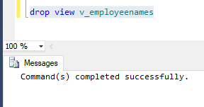

Stored Procedure (Without Parameters)
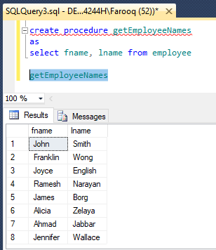
Stored Procedure (With Parameters)
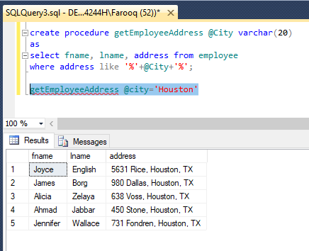
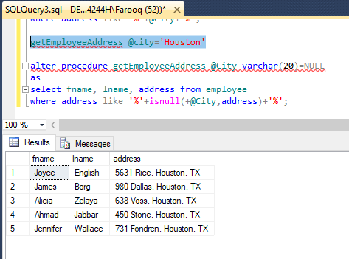
Multiple Parameters
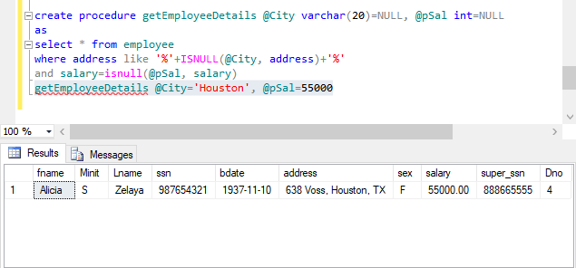
Output parameter
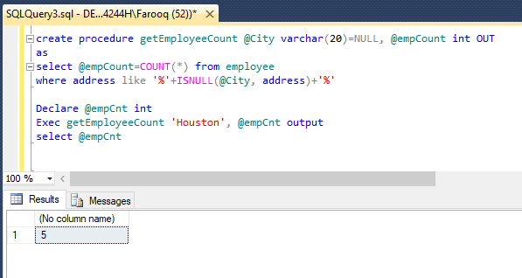

InLab Exercise
1.
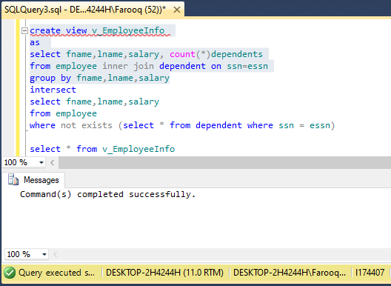
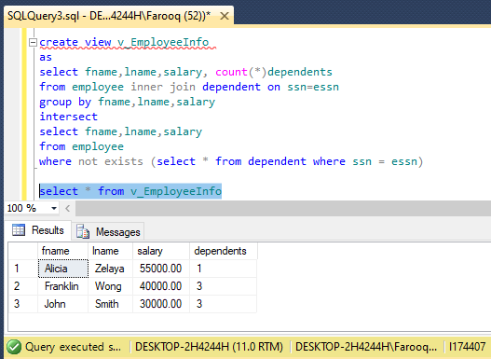

For employees with dependents
create view v_EmployeeInfo
as
select fname,lname,salary, count(*)dependents
from employee inner join dependent on ssn=essn
group by fname,lname,salary

for employees with no dependents
alter view v_EmployeeInfo
as
select fname,lname,salary
from employee
where not exists (select * from dependent where ssn = essn)

select * from v_EmployeeInfo

2. drop view v_EmployeeInfo
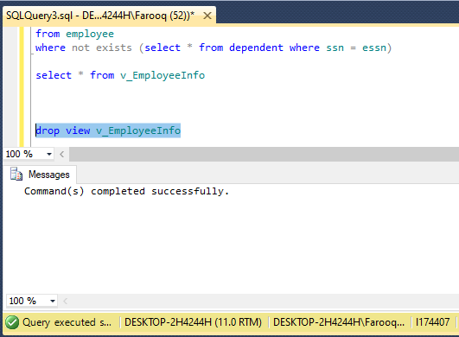

3.
Create procedure p_getManagers_with_Deps
as
select fname,lname from employee
where exists (select * from dependent
where ssn = essn)
and exists (select * from department
where ssn = Mgr_ssn)

p_getManagers_with_Deps

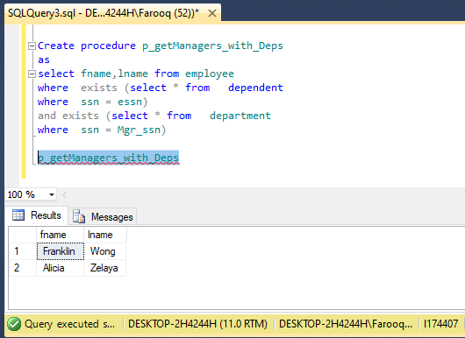

4.
alter procedure p_getManagers_with_Deps
as
select fname+' '+lname EmployeeName, salary
from employee
where exists (select * from dependent
where ssn = essn)
and exists (select * from department
where ssn = Mgr_ssn)

p_getManagers_with_Deps

